**KUST 2024 E-FORMULA**

**CAN Protocol**

**1. System Diagram**

**CAN BUS**

**DL**

**SCU, LV BMS, PM100DX**

**SOC, JCU, HV BMS**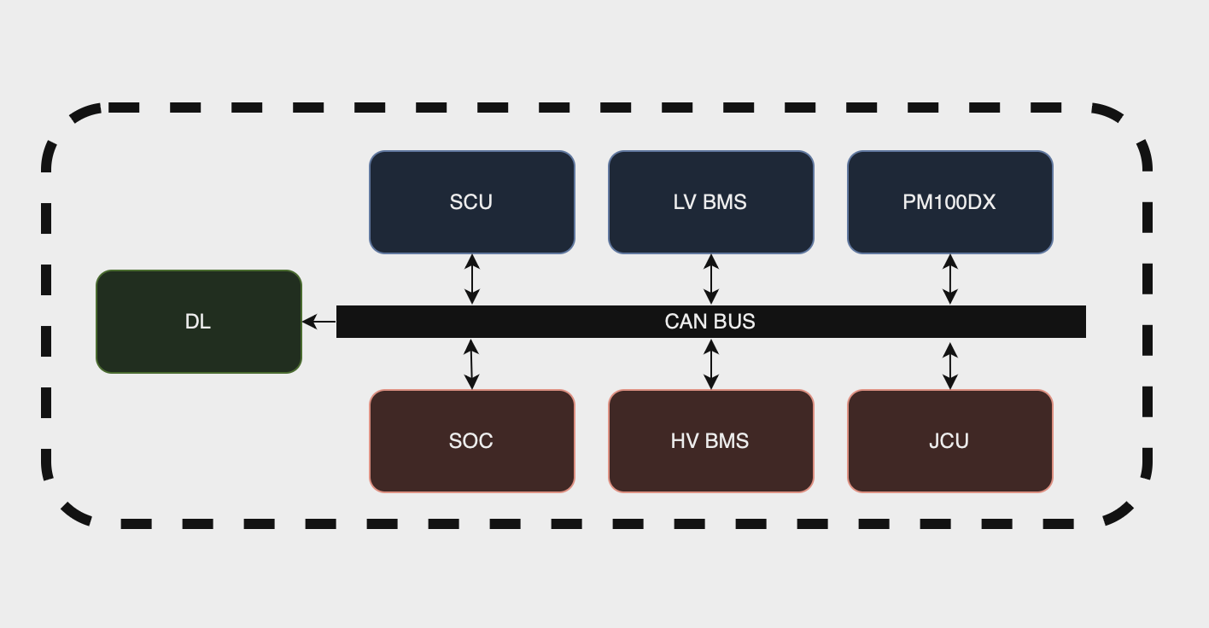

**2. CAN Communication Parameters**

|  |  |
| --- | --- |
| CAN TYPE | CAN 2.0A(standard) |
| Bit Rate | 500kbit/sec |
| ID | 11bit |
| DLC | 8byte |

**3. CAN DATA MAP**

|  |  |  |  |  |  |  |  |  |  |  |  |  |  |  |  |
| --- | --- | --- | --- | --- | --- | --- | --- | --- | --- | --- | --- | --- | --- | --- | --- |
| Byte  CAN-ID | 0 | | 1 | 2 | 3 | | | 4 | | 5 | 6 | 7 | | | |
| HV BMS | | | | | | | | | | | | | | | |
| 0x10 | SEG1[1]  VOLTAGE MAX | | | SEG1 VOLTAGE MIN | | | | SEG1[2]  TEMP MAX | | | SEG1  TEMP MIN | | | | |
| 0x11 | SEG2 VOLTAGE MAX | | | SEG2 VOLTAGE MIN | | | | SEG2  TEMP MAX | | | SEG2  TEMP MIN | | | | |
| 0x12 | SEG3  VOLTAGE MAX | | | SEG3  VOLTAGE MIN | | | | SEG3  TEMP MAX | | | SEG3  TEMP MIN | | | | |
| 0x13 | SEG4  VOLTAGE MAX | | | SEG4  VOLTAGE MIN | | | | SEG4  TEMP MAX | | | SEG4  TEMP MIN | | | | |
| 0x14 | SEG5  VOLTAGE MAX | | | SEG5  VOLTAGE MIN | | | | SEG5  TEMP MAX | | | SEG5  TEMP MIN | | | | |
| 0x15 | PACK VOLTAGE[3] | | | SEG1 VOTAGE | | SEG2 VOTAGE | | SEG3  VOTAGE | SEG4  VOTAGE | | SEG5  VOTAGE | | BMS  STATE | | |
| JCU(Little Endian) | | | | | | | | | | | | | | | |
| 0x20 | AL | TSAL[4] | | AIR1 SIG | | | AIR2 SIG | AIR1 PWR[5] | PRE2 REL[6] | | SDC V[7] | | | | - |
| 0x21 | PRE1 HV V | | | PRE1 MC V | | | | DIS MC V | | | - | | | | - |
| SOC | | | | | | | | | | | | | | | |
| 0x30 | PACK SOC[8] | | | HV Sensor Current[9] | | | | HV Power[10] | | | Peak Current | ~~cnt~~ | | | |
| LV BMS | | | | | | | | | | | | | | | |
| 0x50 | Max Cell  Voltage[11] | | | Min Cell  Voltage | | | | Pack  Voltage | | | Stack  Voltage | | | | |
| 0x51 | ~~Pack Current[12]~~ | | | CELL Temp[13] | | | | FET Temp | | | CONV Temp | | | | |
| 0x52 | hi2c1.ErrorCode | | FET  Status | Safety  Status A | Safety  Status B | | | Safety  Status C | | PF  Status A | PF  Status B | PF  Status C | | | |
| SCU(Little Endian) | | | | | | | | | | | | | | | |
| 0x60 | FR Linear[14] | | | FL Linear | | | | RR Linear | | | RL Linear | | | | |
| 0x61 | FR Wheel Speed | | | FL Wheel Speed | | | | RR Wheel Speed | | | RL Wheel Speed | | | | |
| 0x62 | Steer Linear[15] | | | Brake Pressure1[16] | | | | Brake Pressure2 | | | - | | | - | |
| PM100DX(Little Endian) | | | | | | | | | | | | | | | |
| 0xA0 | Module A Temp[17] | | | Module B Temp | | | | Module C Temp | | | Gate Driver Board Temp | | | | |
| 0xA1 | Control board Temp | | | ~~RTD#1 Temp~~ | | | | ~~RTD#2 Temp~~ | | | ~~RTD#3 Temp~~ | | | | |
| 0xA2 | ~~Coolant Temp~~ | | | ~~Hot Spot Temp~~ | | | | Motor Temp | | | ~~Torque Shudder~~ | | | | |
| ~~0xA4~~ | ~~Forward switch~~ | | ~~Reverse switch~~ | ~~Brake switch~~ | ~~REGEN Disable Switch~~ | | | ~~Ignition switch~~ | | ~~Start switch~~ | ~~Valet Mode~~ | ~~Status of Digital Input~~ | | | |
| 0xA5 | ~~Motor Angle~~ | | | Motor Speed[18] | | | | ~~Electrical Output Frequency~~ | | | ~~Delta Resolver Filtered~~ | | | | |
| 0xA6 | Phase A current | | | Phase B current | | | | Phase C current | | | DC Bus Current | | | | |
| 0xA7 | DC Bus Voltage[19] | | | Output Voltage | | | | ~~VAB Vd Voltage~~ | | | ~~VBC Vd Voltage~~ | | | | |
| 0xA8 | ~~Flux command~~ | | | ~~Flux feedback~~ | | | | Id feedback | | | Iq feedback | | | | |
| 0xA9 | ~~1.5V Reference voltage~~ | | | ~~2.5V Reference voltage~~ | | | | ~~5V Reference voltage~~ | | | ~~12V Reference voltage~~ | | | | |
| 0xAA | VSM State | | ~~PWM~~  ~~Frequency~~ | Inverter State | Relay State | | | ~~1. Inverter Run mode(Bit 0)~~  ~~2. Inverter Active Discharge State~~  ~~(Bits 5-7)~~ | | ~~1. Inverter Command Mode(5-Bit0)~~  ~~2. Rolling Counter Value~~  ~~(5-Bit4 thru 5-Bit7)~~ | ~~1. Inverter Enable State(Bit0)~~  ~~2. Start Mode Active(Bit6)~~  ~~3. Inverter Enable Lockout(Bit7)~~ | ~~1. Direction Command(Bit 0)~~  ~~2. BMS Active~~  ~~(Bit 1)~~  ~~3. BMS Limiting Torque(Bit 2)~~  ~~4. Limit Max Speed(Bit 3)~~  ~~5. Limit Hot Spot(Bit 4)~~  ~~6. Low Speed Limiting(Bit 5)~~  ~~7. Coolant Temperature Limiting(Bit 6)~~ | | | |
| 0xAB | POST Fault Lo | | | POST Fault Hi | | | | Run Fault Lo | | | Run Fault Hi | | | | |
| 0xAC | Command Torque | | | Feedback Torque[20] | | | | Power on Timer | | | | | | | |
| 0xAD | Modulation Index | | | Flux Weakening Output | | | | Id command | | | Iq command | | | | |

**5. 수정사항**

2024-07-10 : ~~빨간글씨(텔레메트리 필요x)~~

2024-07-12 : PM100DX, SCU => default : Little Endian/배수, 단위, ~~빨간글씨~~ 추가

2024-07-15 : 영광TEST피드백 수정사항 반영 완료

2024-07-31 : 7번 각주 Highlight , 11번 각주 Highlight, 상원님 수정 상황 반영 완료, Pm100dx 0xB0, 0xC0, 0xC1, 0xC2삭제, 각주에 들어갈 내용(Unit, Scale)

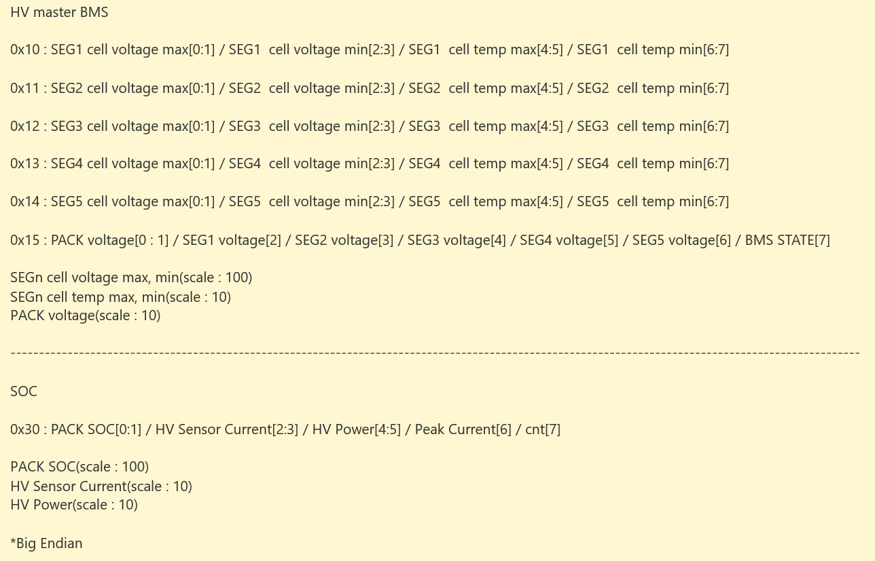

2024-08-10 : LV Charger 영구 삭제, 0x62 4~5 Break Pressure2 추가/HW Diagram 수정 및 재도식화(ccu x, braker temp x, gyro x)/JCU Protocol 수정

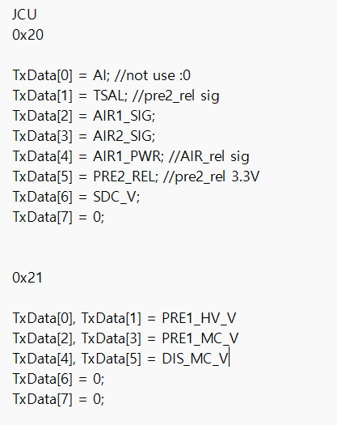

2024-08-12 : JCU => Little Endian, Brake Pressure => Unit, Scale 추가

2024-08-15 : Brake Pressure => 배율이 0.024가 아님. 하단 사진대로 브레이크 압력 센서 값을 계산하는데, 비선형 식이므로 SCU에서 아래의 식대로 계산해서 보내준 값을 받아야 함. VSM STAT도 BSPD 실험 시 봐야하는 중요한 값.

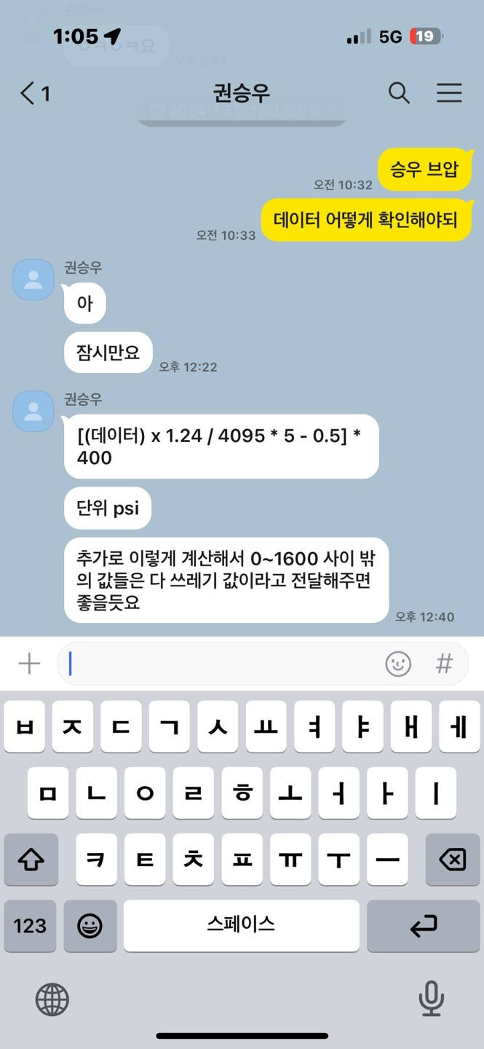

2024-08-30 : PM100dx => FeedBack Torque => Scale 0.1 추가, cnt 삭제

2024-09-09 : LV BMS 추가(Voltage, Current, Temp) => Little Endian

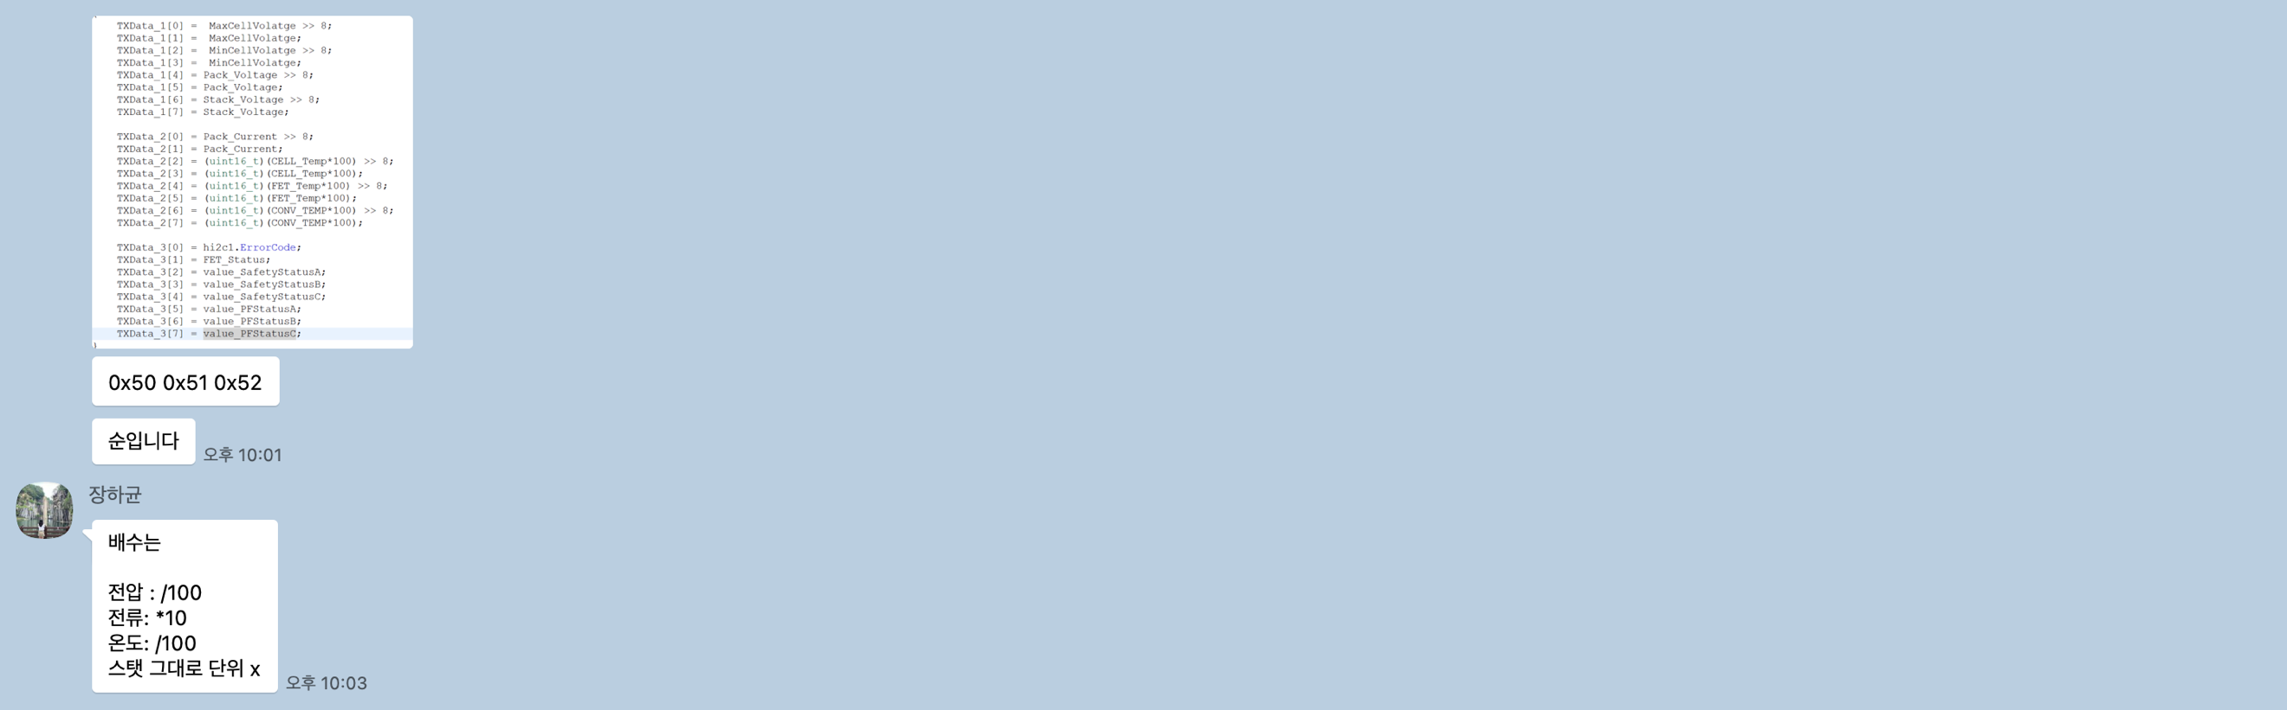

2024-09-27 : LV BMS => 배율 및 엔디안방식 조정

1. SEGn VOLTAGE MAX, MIN(Scale : 0.01)
2. SEGn TEMP MAX, MIN(Scale : 0.1)
3. PACK VOLTAGE(Scale : 0.1)
4. TSAL : PRE2 REL SIG
5. AIR1 PWR : AIR REL SIG
6. PRE2 REL : PRE2 REL 3.3V
7. SDC V, PRE1 HV V, PRE1 MC V, DIS MC V(Scale : 0.001, Unit : mV)
8. PACK SOC(Scale : 0.01)
9. HV Sensor Current(Scale : 0.1)
10. HV Power(Scale : 0.1)
11. Max Cell, Min Cell, Pack, Stack Voltage(Scale : 0.001)
12. Peak Current(Scale : 10)
13. CELL, FET, CONV Temp(Scale : 0.01)
14. FR, FL, RR, RL Linear(Scale : 0.01831)
15. Steer Linear(Scale : 0.036621)
16. Brake Pressure1, 2(Unit : psi)
17. Module n, Gate Driver Board, Control board, Motor Temp(Scale : 0.1)
18. Motor Speed(Unit : RPM)
19. DC Bus Voltage(Scale : 0.1)
20. Feedback Torque(Scale : 0.1)